**Create table facebook**

1. **Find out the total no of users in the dataset**

select count(*) as number_of_user from facebook;

1. **Find out the no of users above the age of 25**

select count(*) from facebook where age > 25;

1. **Do male face book users tend to have more friends or female users**

select gender,count(friend_count) as number_of_friends from facebook group by gender;

1. **Find out the count of facebook users for each birthday month**

select dob_month,count(userid) as number_of_user from facebook group by dob_month;

1. **How many likes do young people receive on facebook as opposed to old people**

select case when age <= 18 then 'old' when

age > 18 then 'young' end age,sum(likes) as number_of_likes from facebook group by case when age <= 18 then 'old' when age > 18 then '

young' end

1. **Do adult members use mobile phones or computers for facebook browsing**

select sum(mobile_likes) as mobile_likes,sum(mobile_likes_received) as mubile_like_recived,su

m(www_likes) as computer_likes,sum(www_likes_received) as computer_like_recived from facebook where age > 18;

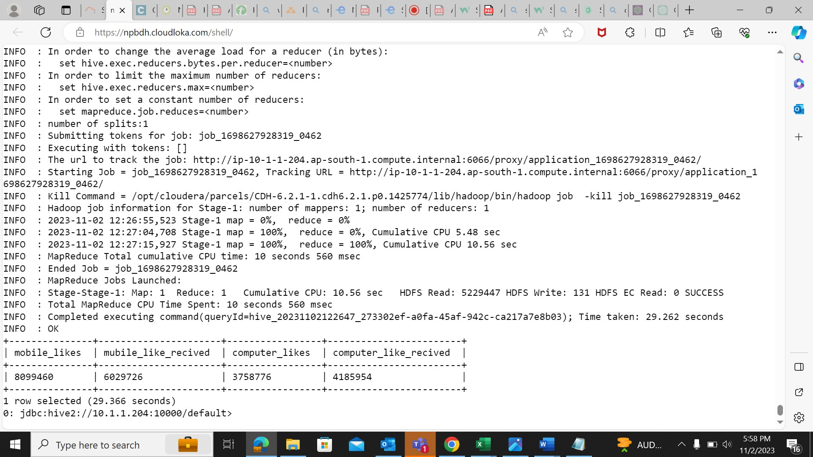

1. **Do young members use mobile phones or computers for facebook browsing**

select sum(mobile_likes) as mobile_likes,sum(mobile_likes_received) as mubile_like_recived,su

m(www_likes) as computer_likes,sum(www_likes_received) as computer_like_recived from facebook where age < 18;

